ST. XAVIER'S COLLEGE

**(Affiliated to Tribhuvan University)**

Maitighar, Kathmandu



**COMPUTER GRAPHICS**

**LAB ASSIGNMENT # 1**

**SUBMITTED BY:**

Abhishek Tamrakar  
013BSCCSIT003

2nd Year/4th Sem

**SUBMITTED TO:**

|  |  |
| --- | --- |
| **Er. Anil Kumar Sah**  Supervisor,  Department of Computer Science  St. Xavier’s College |  |

**Date of Submission:** 4th August 2015

**STATEMENT: “DRAW THE FOLLOWING CHECKBOX”**

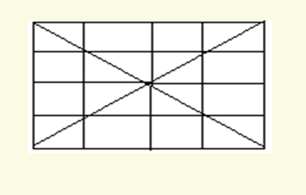

**PROGRAM CODE:**

//---------------------------------------------------------------------------

#include <vcl\vcl.h>

#pragma hdrstop

#include "line2.h"

//---------------------------------------------------------------------------

#pragma resource "*.dfm"

TForm1 *Form1;

//---------------------------------------------------------------------------

__fastcall TForm1::TForm1(TComponent* Owner)

: TForm(Owner)

{

}

//---------------------------------------------------------------------------

void __fastcall TForm1::Button1Click(TObject *Sender)

{

Form1->Canvas->MoveTo(10,10);

Form1->Canvas->LineTo(200,200);

Form1->Canvas->MoveTo(10,10);

Form1->Canvas->LineTo(10,200);

Form1->Canvas->MoveTo(10,10);

Form1->Canvas->LineTo(200,10);

Form1->Canvas->MoveTo(10,200);

Form1->Canvas->LineTo(200,200);

Form1->Canvas->MoveTo(10,200);

Form1->Canvas->LineTo(200,10);

Form1->Canvas->MoveTo(200,10);

Form1->Canvas->LineTo(200,200);

Form1->Canvas->MoveTo(55,10);

Form1->Canvas->LineTo(55,200);

Form1->Canvas->MoveTo(105,10);

Form1->Canvas->LineTo(105,200);

Form1->Canvas->MoveTo(155,10);

Form1->Canvas->LineTo(155,200);

Form1->Canvas->MoveTo(10,55);

Form1->Canvas->LineTo(200,55);

Form1->Canvas->MoveTo(10,105);

Form1->Canvas->LineTo(200,105);

Form1->Canvas->MoveTo(10,105);

Form1->Canvas->LineTo(200,155);

}

//---------------------------------------------------------------------

**OUTPUT:**

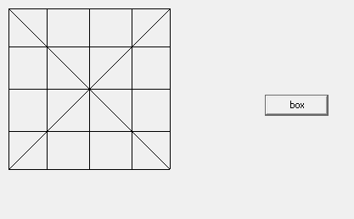

**CONCLUSION:**

Hence, the above checkbox was drawn using the LineTo and MoveTo functions in C++ Builder.